**DVLA Functional Unit Test Results:**

1. Check if user can run “dvlasearch.ListFileDetailsInADirectory “, to list different types of files and also list any directory in the configured folder, configured to search in “src\test\resources\files”.

Result: All files and Directory currently in the Folder is listed as expected:

In Windows Explorer:

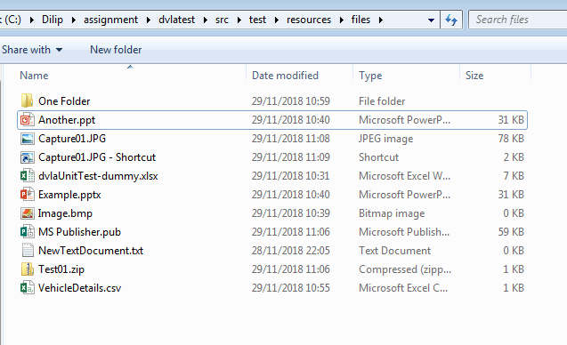

In Console showing the file and folder details:

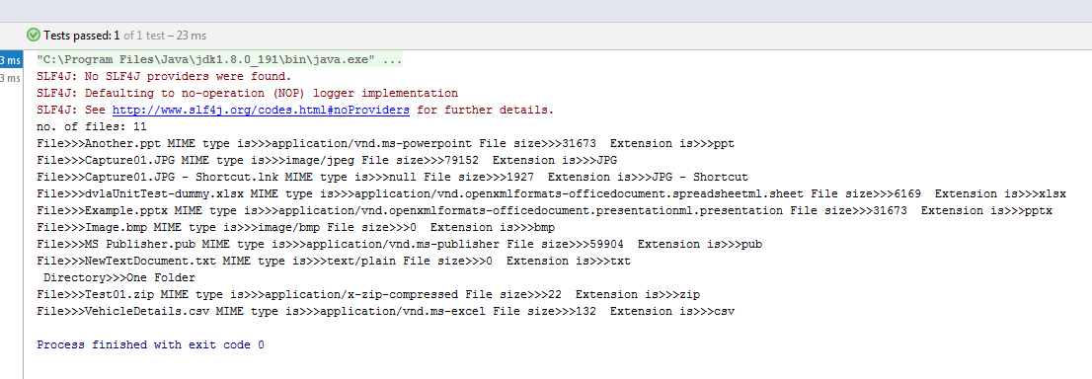

1. Check if user can run “dvlasearch.runners.DVLASearchUtility “, to check vehicle details in the CSV file

Assumptions: Vehicle details are saved in a csv file with multiple vehicle details

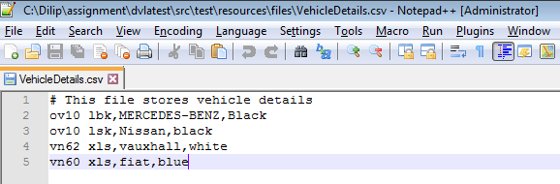

Test runs as expected and verify the Make and Colour details against each row of data in the CSV file.

